**Tek School of America**

**Maven, GIT and Jenkins**

**Interview Questions**

**What is Maven Tool?**

A) Maven is a build automation tool used primarily for Java projects. Maven is a build automation tool used primarily for Java projects.

**Why should we use Maven?**

A) Maven is a powerful project management tool that is based on POM (project object model). It is used for projects build, dependency and documentation. Maven repository is a directory of packaged JAR file with pom.xml file. Maven searches for dependencies in the repositories.

**What is a Maven POM file?**

A) A Project Object Model or POM is the fundamental unit of work in Maven. It is an XML file that contains information about the project and configuration details used by Maven to build the project. It contains default values for most projects.

**What are the repositories in Maven?**

A) In Maven terminology, a repository is a directory where all the project jars, library jar, plugins or any other project specific artifacts are stored and can be used by Maven easily.

**What does Maven dependency plugin do?**

A) Apache Maven Dependency Plugin. The dependency plugin provides the capability to manipulate artifacts. It can copy and/or unpack artifacts from local or remote repositories to a specified location.

**What is meant by a goal in Maven?**

A) Executing a phase means executes all previous phases. Plugin is a collection of goals. Plugin is a class and goals are methods within the class. Maven is based around the central concept of a build lifecycle.

**Where are Maven dependencies downloaded to?**

A) The jars , dependency files and other files which are downloaded by Maven reside in the Maven local repository. By default the Maven local repository is the .m2 folder. You can copy the jar directly into where it is meant to go. Maven will find this file next time it is runs.

**What is the use of Maven clean?**

1. The Maven Clean Plugin, as the name implies, attempts to clean the files and directories generated by Maven during its build. While there are plugins that generate additional files, the Clean Plugin assumes that these files are generated inside the target directory.

**Where are Maven dependencies stored?**

A) The maven local repository is a local folder that is used to store all your project’s dependencies (plugin jars and other files which are downloaded by Maven). In simple, when you build a Maven project, all dependency files will be stored in your Maven local repository.

**How do you tell Maven to use the latest version of a dependency?**

In Maven, dependencies are usually set up like this:

<dependency>  
<groupId>wonderful-inc</groupId>  
<artifactId>dream-library</artifactId>  
<version>1.2.3</version>  
</dependency>

**How do you find Oracle JDBC driver in Maven repository?**

I want to add the oracle jdbc driver to my project as dependency (runtime scope) – ojdbc14. In MVNrepository site the dependency to put in the POM is:

<dependency>  
<groupId>com.oracle</groupId>  
<artifactId>ojdbc14</artifactId>  
<version>10.2.0.3.0</version>  
</dependency>

**What is force maven update?**

A) mvn clean install -U  
-U means force update of snapshot dependencies. Release dependencies can’t not be updated this way.

**What is GIT?**

GIT is a distributed version control system and source code management (SCM) system with an emphasis to handle small and large projects with speed and efficiency.

**What is a repository in GIT?**

A repository contains a directory named .git, where git keeps all of its metadata for the repository. The content of the .git directory are private to git.

**What is the command you can use to write a commit message?**

The command that is used to write a commit message is “git commit –a”.  The –a on the command line instructs git to commit the new content of all tracked files that have been modified. You can use “git add<file>” before git commit –a if new files need to be committed for the first time.

**What is the difference between GIT and SVN?**

The difference between GIT and SVN is

a)      Git is less preferred for handling extremely large files or frequently changing binary files while SVN can handle multiple projects stored in the same repository.

b)      GIT does not support ‘commits’ across multiple branches or tags.  Subversion allows the creation of folders at any location in the repository layout.

c)        Gits are unchangeable, while Subversion allows committers to treat a tag as a branch and to create multiple revisions under a tag root.

**What are the advantages of using GIT?**

a)      Data redundancy and replication

b)      High availability

c)       Only one.git directory per repository

d)      Superior disk utilization and network performance

e)      Collaboration friendly

f)       Any sort of projects can use GIT

**What is the function of ‘GIT PUSH’ in GIT?**

‘GIT PUSH’ updates remote refs along with associated objects.

**What is the function of git clone?**

The git clone command creates a copy of an existing Git repository.  To get the copy of a central repository, ‘cloning’  is the most common way used by programmers.

**What is the function of ‘git config’?**

The ‘git config’ command is a convenient way to set configuration options for your Git installation.  Behaviour of a repository, user info, preferences etc. can be defined through this command.

**What does commit object contain?**

a)      A set of files, representing the state of a project at a given point of time

b)      Reference to parent commit objects

c)       An SHAI name, a 40 character string that uniquely identifies the commit object.

**How can you create a repository in Git?**

In Git, to create a repository, create a directory for the project if it does not exist, and then run command “git init”. By running this command .git directory will be created in the project directory, the directory does not need to be empty.

**What is ‘head’ in git and how many heads can be created in a repository?**

A ‘head’ is simply a reference to a commit object. In every repository, there is a default head referred as “Master”.  A repository can contain any number of heads.

**What is the purpose of branching in GIT?**

The purpose of branching in GIT is that you can create your own branch and jump between those branches. It will allow you to go to your previous work keeping your recent work intact.

**What is the common branching pattern in GIT?**

The common way of creating branch in GIT is to maintain one as “Main“

branch and create another branch to implement new features. This pattern is particularly useful when there are multiple developers working on a single project.

**How can you bring a new feature in the main branch?**

To bring a new feature in the main branch, you can use a command “git merge” or “git pull command”.

**What is a ‘conflict’ in git?**

A ‘conflict’ arises when the commit that has to be merged has some change in one place, and the current commit also has a change at the same place. Git will not be able to predict which change should take precedence.

**How can conflict in git resolved?**

To resolve the conflict in git, edit the files to fix the conflicting changes and then add the resolved files by running “git add” after that to commit the repaired merge,  run “git commit”.  Git remembers that you are in the middle of a merger, so it sets the parents of the commit correctly.

**To delete a branch what is the command that is used?**

Once your development branch is merged into the main branch, you don’t need

development branch.  To delete a branch use, the command “git branch –d [head]”.

**What is the difference between ‘git remote’ and ‘git clone’?**

‘git remote add’  just creates an entry in your git config that specifies a name for a particular URL.  While, ‘git clone’ creates a new git repository by copying and existing one located at the URI.

**What is ‘git status’ is used for?**

As ‘Git Status’ shows you the difference between the working directory and the index, it is helpful in understanding a git more comprehensively

**What is Jenkins?**

**Answer:**Jenkins is a free open source Continuous Integration tool and automation server to monitor continuous integration and delivery. It is written in Java.

It is known as an automated Continuous Delivery tool that helps to build and test the software system with easy integration of changes to the system. Jenkins follows Groovy Scripting.

Also, it enables developers to continuously check in their code and also analyze the post-build actions. The automation testers can use to run their tests as soon as the new code is added or code is modified.

**What are the features of Jenkins?**

**Answer: Jenkins comes with the following features:**

1. Free open source.
2. Easy installation on various operating systems.
3. Build Pipeline Support.
4. Workflow Plugin.
5. Test harness built around JUnit.
6. Easy upgrades.
7. Rapid release cycle.
8. Easy configuration setup.
9. Extensible with the use of third-party plugins.

**What are the advantages of Jenkins? Why we use Jenkins?**

**Answer:**Jenkins is used to continuously monitor the large code base in real time. It enables developers to find bugs in their code and fix. Email notifications are made to the developers regarding their check-ins as a post-build action.

**Advantages of Jenkins are as follows:**

* Build failures are cached during the integration stage.
* Notifies the developers about build report status using LDAP (Lightweight Directory Access Protocol) mail server.
* Maven release project is automated with simple steps.
* Easy bug tracking.
* Automatic changes get updated in the build report with notification.
* Supports Continuous Integration in agile development and test-driven development.

**Mention some of the important plugins in Jenkins?**

**Answer: Plugins in Jenkins includes:**

* Gits
* Maven 2 Project
* HTML Publisher
* Copy Artcraft
* Join
* Green Balls
* Amazon EC2

**What is Continuous Integration in Jenkins?**

**Answer:**Continuous integration is the process of continuously checking-in the developer’s code into a version control system and triggering the build to check and identify bugs in the written code.

**This is a very quick process and also gives them a chance to fix the bugs. Jenkins is one such continuous integration tool.**

In software development, multiple developers work on different software modules.

While performing integration testing all the modules are being integrated together. It is considered as the development practice to integrate the code into the source repository

Whenever the programmer/developer makes any change to the current code, then it automatically  
gets integrated with the system running on the tester’s machine and makes the testing task easy and speedy for the system testers.

**Continuous Integration comprises of:**

* Development and Compilation
* Database Integration
* Unit Testing
* Production Deployment
* Code Labeling
* Functional Testing
* Generating and Analyzing Reports

**What is Jenkins pipeline? What is a CI CD pipeline?**

**Answer:**The pipeline can be defined as the suite of plugins supporting implementation and  
integration of continuous delivery pipelines in Jenkins.

Continuous integration or continuous delivery pipeline consists of build, deploy, test, release pipeline. The pipeline feature saves a lot of time and error in maintaining the builds. Basically, a pipeline is a group of build jobs that are chained and integrated in sequence.

**What are Scripted Pipelines in Jenkins?**

**Answer:**Scripted Pipeline follows Groovy

**What are Triggers?**

**Answer:**Trigger in Jenkins defines the way in which the pipeline should be executed  
frequently. PollSCM, Cron, etc are the currently available Triggers.

**How to make sure that your project build does not break in Jenkins?**

**Answer:**You need to follow the below-mentioned steps to make sure that the Project build does not break:

1. Clean and successful installation of Jenkins on your local machine with all unit tests.
2. All code changes are reflected successfully.
3. Checking for repository synchronization to make sure that all the differences and changes related to config and other settings are saved in the repository.
4. **How you can set up a Jenkins job?**
5. **Answer:**
6. **Setting up a new job in Jenkins is elaborated below with snapshots:**
7. **Step 1:**Go to the Jenkins Dashboard and Login with your registered login credentials.
8. [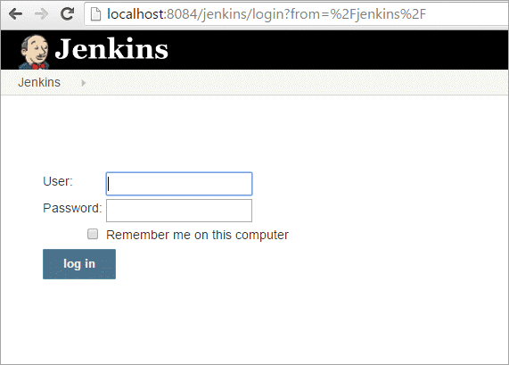](https://cdn.softwaretestinghelp.com/wp-content/qa/uploads/2019/02/Screen-1.1.png)
9. **Step 2:**Click on the**New Item**that is shown in the left panel of the page.
10. [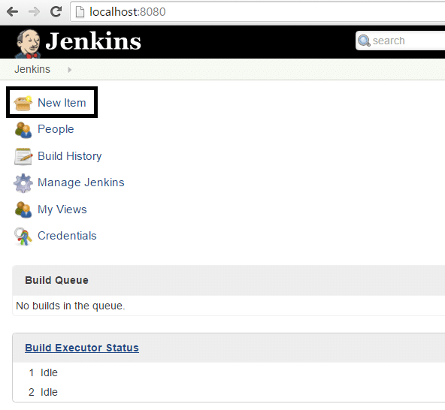](https://cdn.softwaretestinghelp.com/wp-content/qa/uploads/2019/02/Screen-2-3.png)
11. **Step 3:**Click on the**Freestyle Project**from the given list on the upcoming page and specify  
    the item name in the text box.
12. [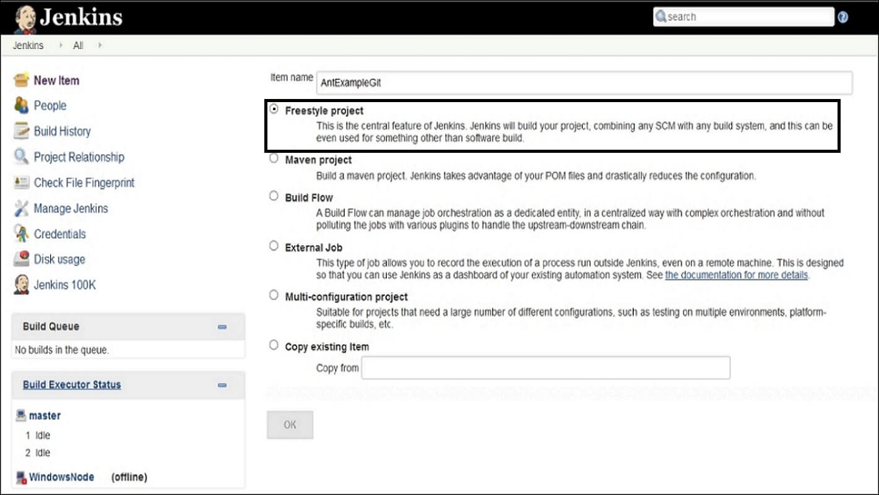](https://cdn.softwaretestinghelp.com/wp-content/qa/uploads/2019/02/Screen-3.jpg)
13. **Step 4:**Add the **URL to Git** Repository.
14. [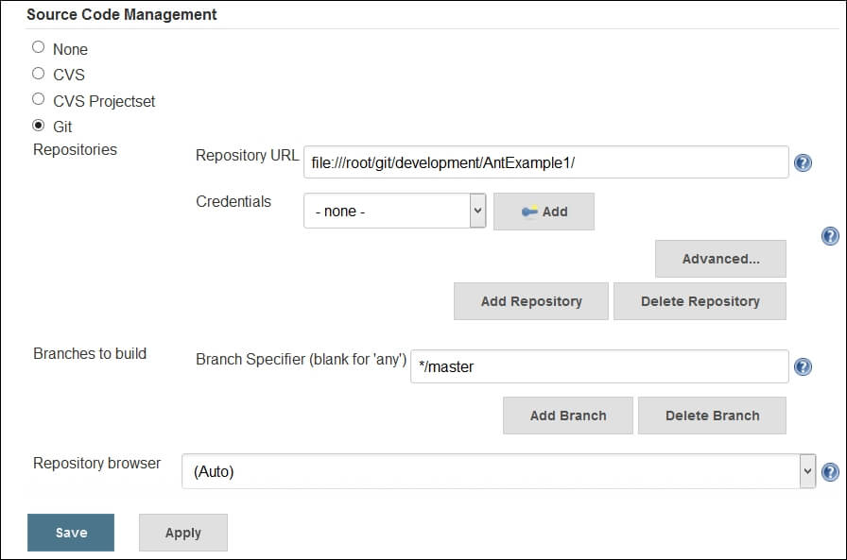](https://cdn.softwaretestinghelp.com/wp-content/qa/uploads/2019/02/Screen-4.jpg)
15. **Step 5:**Go to the **Build section and click on the Add build step => Execute Windows batch  
    command.**
16. [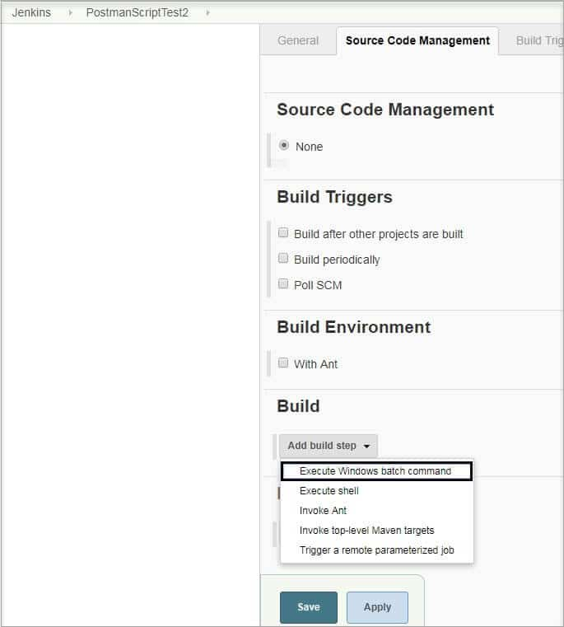](https://cdn.softwaretestinghelp.com/wp-content/qa/uploads/2019/02/Screen-5-4.jpg)
17. **Step 6:** Enter the command in the **command window** as shown below.
18. [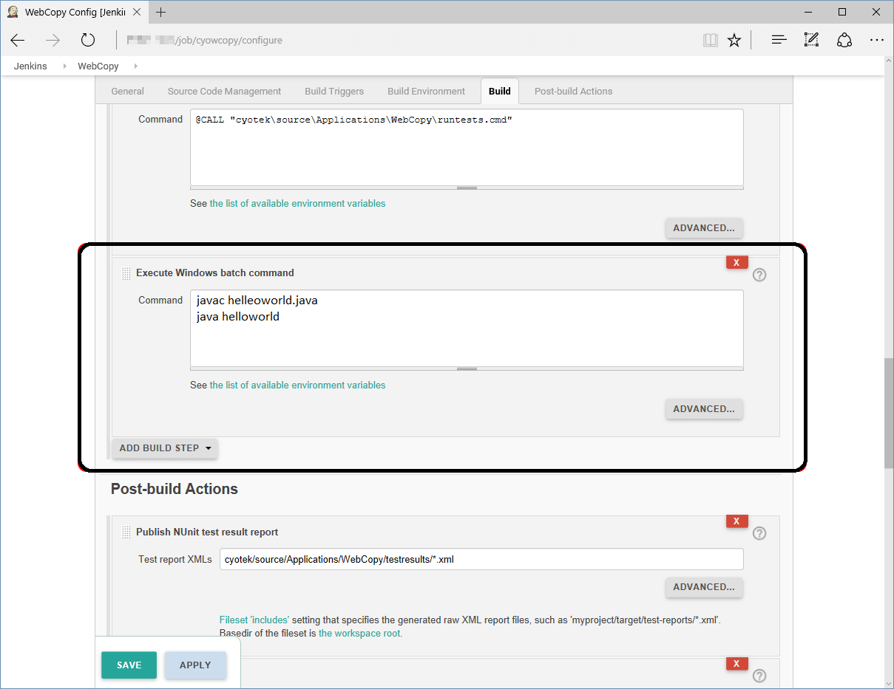](https://cdn.softwaretestinghelp.com/wp-content/qa/uploads/2019/02/Screen-6.png)
19. **Step 7:** After saving all the settings and changes click on **Build Now.**
20. [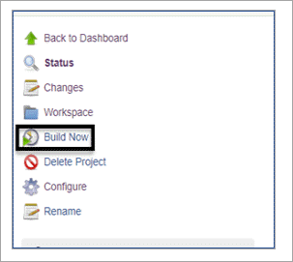](https://cdn.softwaretestinghelp.com/wp-content/qa/uploads/2019/03/Screen-7.png)
21. **Step 8:** To see the status of the build click on **Console Output.**
22. [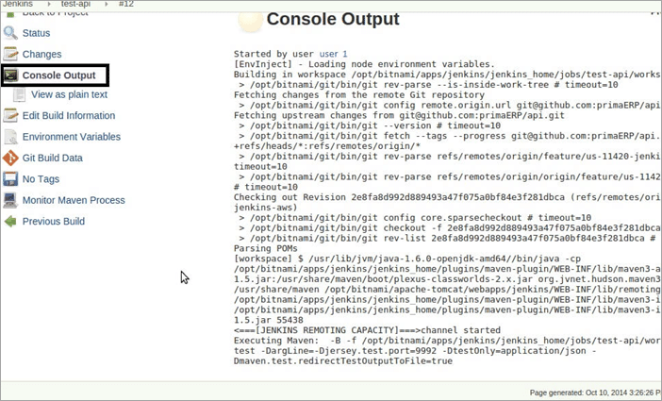](https://cdn.softwaretestinghelp.com/wp-content/qa/uploads/2019/02/8-click-on-Console.png)

**What are the two components (pre-requisites) that Jenkins is mainly integrated with?**

**Answer: Jenkins integrates with:**

1. Build tools/ Build working script like Maven script.
2. Version control system/Accessible source code repository like Git repository.

**How can You Clone a Git Repository via Jenkins?**

**Answer:** To create a clone repository via Jenkins you need to use your login credentials in the Jenkins System.

To achieve the same you need to enter the Jenkins job directory and execute the **git config**

command.

**What is the solution if you find a broken build for your project?**

**Answer: To resolve the broken build follow the below-mentioned steps:**

(i) Open console output for the build and check if any file change has missed.

**OR**

(ii) Clean and update your local workspace to replicate the problem on the local system and try to resolve it (In case you couldn’t find out the issue in the console output).

**What are the various ways in which the build can be scheduled in Jenkins?**

**Answer: The build can be triggered in the following ways:**

1. After the completion of other builds.
2. By source code management (modifications) commit.
3. At a specific time.
4. By requesting manual builds.

**Why is Jenkins called a Continuous Delivery Tool?**

**Answer:** We have seen the Continuous Delivery workflow in the previous question, now let's see the step by step process of why Jenkins is being called as a Continuous Delivery Tool:

1. Developers work on their local environment for making changes in the source code and push it into the code repository.
2. When a change is detected, Jenkins performs several tests and code standards to check whether the changes are good to deploy or not.
3. Upon a successful build, it is being viewed by the developers.
4. Then the change is deployed **manually** on a staging environment where the client can have a look at it.
5. When all the changes get approved by the developers, testers, and clients, the final outcome is saved **manually**on the production server to be used by the end users of the product.

In this way, Jenkins follows a **Continuous Delivery approach** and is called the **Continuous  
Delivery Tool.**